**Labsheet-2**

**Map Reduce**

**Name : Anuvind M P**

**Roll : AM.EN.U4AIE22010**

**export PATH=$PATH:$HADOOP_HOME/bin:$HADOOP_HOME/sbin**

**cd $HADOOP_HOME/sbin**

**./start-all.sh**

**Output :**

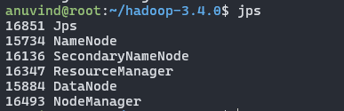

1. ***hdfs dfs -mkdir /bigdata***



1. ***hdfs dfs -touchz /bigdata/input***

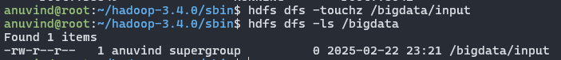

1. ***hdfs dfs -appendToFile -/bigdata /input***

***aaaaa bbbb cc aaaaa cc***

***cc bbbb zzzz ctrl+d ctrl+ d***



1. ***cd $HADOOP_HOME***
2. ***ls***
3. ***cd share***
4. ***ls***
5. ***cd Hadoop***
6. ***ls***
7. ***cd mapreduce***
8. ***ls***

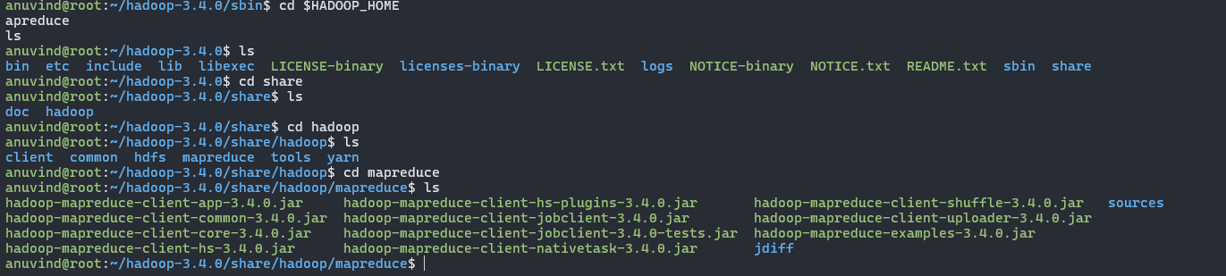

1. ***hadoop jar hadoop-mapreduce-examples-3.3.0.jar wordcount /bigdata /out***

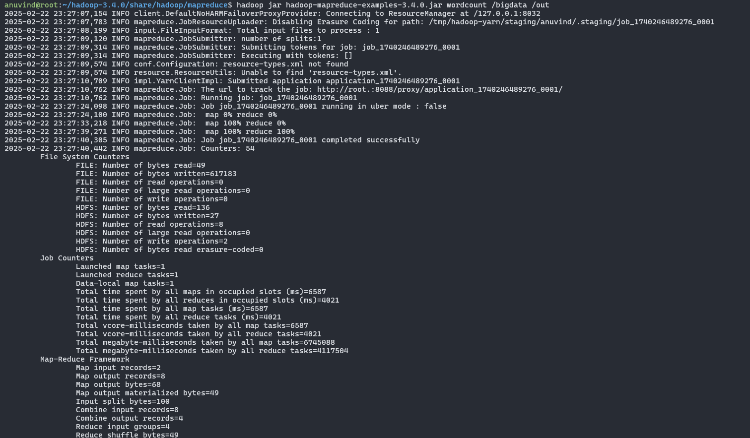

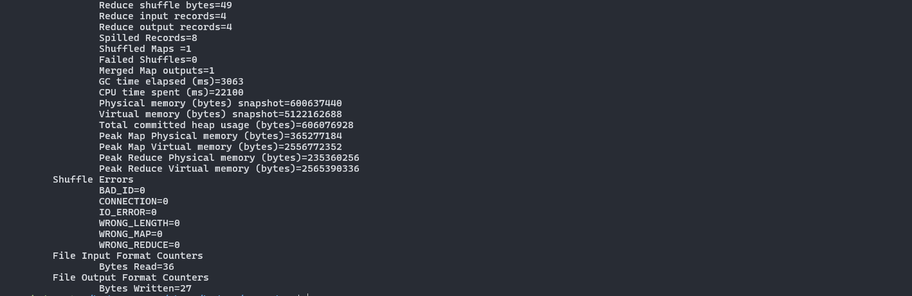

1. ***hdfs dfs -ls /out***

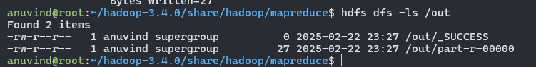

1. ***hdfs dfs -cat /out/part\****

